INSTRUCTIONS FOR MEASURING HEIGHT AND WEIGHT
OF BOTH RESPONDENTS AND CHILDREN¹

I. PROCEDURES AND PRECAUTIONS BEFORE MEASURING

A. Layout of the Procedures
Each step of the measurement procedures is directed at specific participants, who are named in bold letters at the beginning of each step: e.g. "Measurer", "Assistant", etc.

B. Two Trained People Required
Two trained people are required to measure a child's height and length. The measurer holds the child and takes the measurements. The assistant helps hold the child and records the measurements on the questionnaire. If there is an untrained assistant such as the mother, then the trained measurer should also record the measurements on the questionnaire. One person alone can take the weight of a child and record the results if an assistant is not available.

C. Measuring Board and Scale Placement
Be selective about where you place the measuring board and scale. Make sure there is adequate light. In many situations, it is best to measure outdoors during daylight hours. If it is cold, raining or if too many people congregate and interfere with the measurements, it may be necessary to weigh and measure indoors.

D. When to Weigh and Measure
Weigh and measure after you have conducted the individual interview. This will allow you to become familiar with the members of the household. DO NOT weigh and measure at the beginning of the interview, i.e., as soon as you enter a household, since it may be perceived as an upsetting intrusion.

E. Weigh and Measure One Child at a Time
If there is more than one eligible child in a household, complete the weighing and measuring of one child at a time. Then proceed with the next eligible child.

Before beginning to measure the child, check that you have entered the name and line number for the child from the household schedule correctly at the top of the column in which you are planning to record the measurements.

If there is more than one eligible woman in a household, weigh and measure her and all her eligible children before proceeding with the next woman and any children she may have. DO NOT weigh and measure all the children together. Otherwise measurements may get recorded in the wrong columns of the questionnaire. Return measuring equipment to their storage bags immediately after you complete the measurements for each household.

F. Age Assessment
Before you measure, record the child’s exact birth date in Q. 503. If the child’s mother was interviewed during the survey, record the month and year of birth from the birth history and ask for the day on which the child was born. If the mother was not interviewed, obtain the child’s birth complete date of birth (day, month and year). When recording the birth date, make sure that you enter the day first followed by the month.

Using the birth date, determine the child's age. If the child is less than 24 months (two years) old, measure the length (that is, with the child lying down). If the child is 24 months (two years) of age or older, measure height (that is, with the child standing up). If accurate age information is not possible to obtain, measure the length and record the measurement if the child is less than 85 cm. If the child is equal to or greater than 85 cm, you should obtain a second measurement with the child standing and record that value.

G. Control the Child
When you weigh and measure, you must control the child. The strength and mobility of even very young children should not be underestimated. Be firm yet gentle with children. Your own sense of calm and self confidence will be felt by the mother and the child.

When a child has contact with any measuring equipment, i.e., on a measuring board you must hold and control the child so the child will not trip or fall. Never leave a child alone with a piece of equipment.

H. Coping with Stress
Explain the weighing and measuring procedures to the mother, and to a limited extent, the child, to help minimize possible resistance, fears or discomfort they may feel. You must determine if the child or mother is under so much stress that the weighing and measuring must stop. Remember, young children are often uncooperative; they tend to cry, scream, kick and sometimes bite. If a child is under severe stress and is crying excessively, try to calm the child or return the child to the mother before proceeding with the measuring.

Do not weigh or measure a child if:

- The mother refuses.
- The child is too sick or distressed.
- The child is physically deformed which will interfere with or give an incorrect measurement. To be kind, you may want to measure such a child and make a note of the deformity on the questionnaire.

I. Recording Measurements and Being Careful
Keep objects out of your hands and pens out of your mouth, hair or breast pocket when you weigh and measure so that neither the child nor you will get hurt due to carelessness. When you are not using a pen, place it in your equipment pack or on the questionnaire. Make sure you do not have long fingernails. Remove interfering rings and watches before you weigh and measure.

J. Strive for Improvement
You can be an expert measurer if you strive for improvement and follow every step of every procedure the same way every time. The quality and speed of your measurements will improve with practice. You will be required to weigh and measure woman children. Do not take these procedures for granted even though they may seem simple and repetitious. It is easy to make errors when you are not careful. Do not omit any steps. Concentrate on what you are doing.
II. HEIGHT, SUMMARY OF PROCEDURES

A. CHILD'S HEIGHT (Illustration 1)

1. Measurer or Assistant: Place the measuring board on a hard flat surface against a wall, table, tree, staircase, etc. Make sure the board is stable.

2. Measurer or Assistant: Ask the mother to remove the child's shoes and upbraid any hair that would interfere with the height measurement. Ask her to walk the child to the board and to kneel in front of the child (if she is not the assistant).

3. Assistant: Place the questionnaire and pen on the ground (Arrow 1). Kneel with both knees on the right side of the child. (Arrow 2).

4. Measurer: For mobility, kneel on your right knee only, on the child's left side (Arrow 3).

5. Assistant: Place the child's feet flat and together in the center of and against the back and base of the board. Place your right hand just above the child's ankles on the shins (Arrow 4), your left hand on the child's knees (Arrow 5) and push against the board. Make sure the child's legs are straight and the heels and calves are against the board (Arrows 6 and 7). Tell the measurer when you have completed positioning the feet and legs.

6. Measurer: Tell the child to look straight ahead at the mother if she is in front of the child. Make sure the child's line of sight is level with the ground (Arrow 8). Place your open left hand on the child's chin. Gradually close your hand (Arrow 9). Do not cover the child's mouth or ears. Make sure the shoulders are level (Arrow 10), the hands are at the child's side (Arrow 11), and the head, shoulder blades and buttocks are against the board (Arrows 12, 13, 14). With your right hand, lower the headpiece on top of the child's head. Make sure you push through the child's hair (Arrow 15).

7. Measurer and Assistant: Check child's position (Arrows 1-15). Repeat any steps as necessary.

8. Measurer: When the child's position is correct, read and call out the measurement to the nearest 0.1 cm. Remove the headpiece from the child's head, your left hand from the child's chin and support the child during the recording.

9. Assistant: Immediately record the measurement and show it to the measurer. Note: If the assistant is untrained, the measurer records the height.

10. Measurer: Check the recorded measurement on the questionnaire for accuracy and legibility. Instruct the assistant to correct any errors.

B. WOMAN'S HEIGHT
Measure the height of the respondent in the same way you do for older children. Make sure that any scarves are removed and that her hairstyle does not interfere with the measurement. You must use all extension pieces for the measuring board. While measuring, you should be careful to respect her modesty when checking that she is standing straight against the board.
Illustration 1
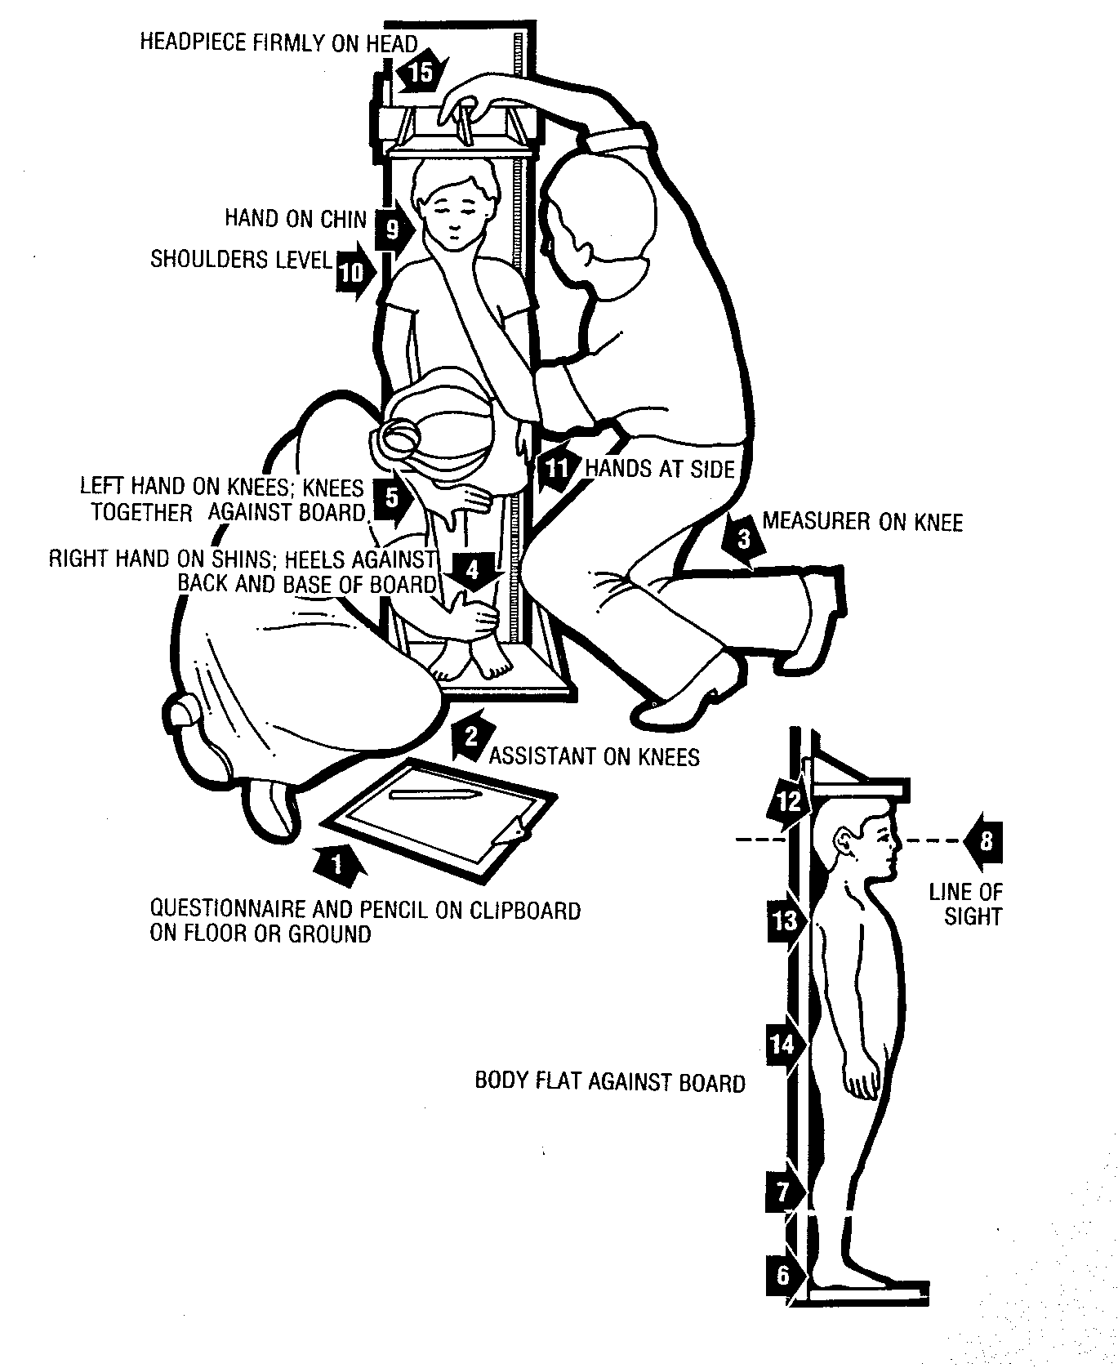
C. CHILD'S LENGTH (Illustration 2)

1. Measurer or Assistant: Place the measuring board on a hard flat surface, i.e. ground, floor or steady table.

2. Assistant: Place the questionnaire and pen on the ground, floor or table (Arrow 1). Kneel with both knees behind the base of the board, if it is on the ground or floor (Arrow 2).

3. Measurer: Kneel on the right side of the child so that you can hold the foot piece with your right hand (Arrow 3).

4. Measurer and Assistant: With the mother's help, lay the child on the board by doing the following:

Assistant: Support the back of the child's head with your hands and gradually lower the child onto the board.
Measurer: Support the child at the trunk of the body.

5. Measurer or Assistant: If she is not the assistant, ask the mother to kneel on the opposite side of the board facing the measurer to help keep the child calm.

6. Assistant: Cup your hands over the child's ears (Arrow 4). With your arms comfortably straight (Arrow 5), place the child's head against the base of the board so that the child is looking straight up. The child's line of sight should be perpendicular to the ground (Arrow 6). Your head should be straight over the child's head. Look directly into the child's eyes.

7. Measurer: Make sure the child is lying flat and in the center of the board (Arrow 7). Place your left hand on the child's shins (above the ankles) or on the knees (Arrow 8). Press them firmly against the board. With your right hand, place the foot piece firmly against the child's heels (Arrow 9).

8. Measurer and Assistant: Check the child's position (Arrows 1-9). Repeat any steps as necessary.

9. Measurer: When the child's position is correct, read and call out the measurement to the nearest 0.1 cm. Remove the foot piece, release your left hand from the child's shins or knees and support the child during the recording.

10. Assistant: Immediately release the child's head, record the measurement, and show it to the measurer. Note: If the assistant is untrained, the measurer records the length on the questionnaire.

11. Measurer: Check the recorded measurement on the questionnaire for accuracy and legibility. Instruct the assistant to correct any errors.
Illustration 2
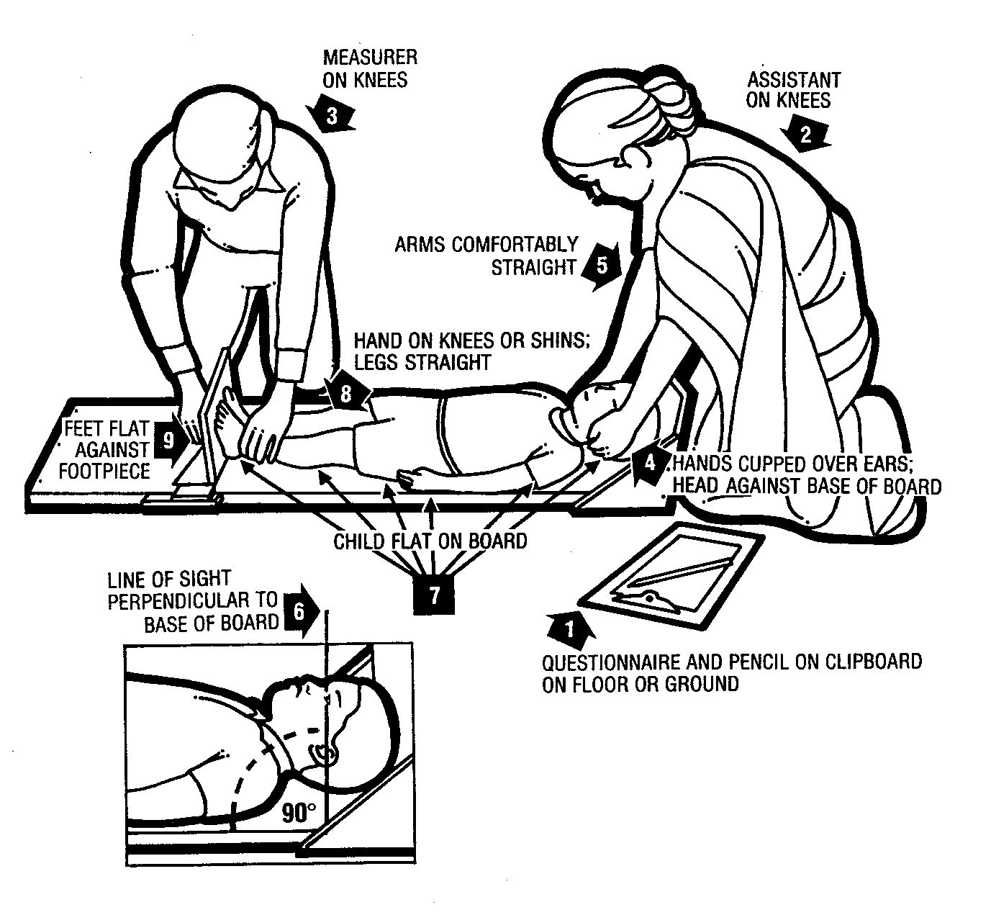
III. WEIGHT, SUMMARY OF PROCEDURES FOR WEIGHING WOMEN AND CHILDREN³

A. Equipment:
1. Digital scale (UNICEF Electronic Scale or Uniscale⁴) for weighing both children and adults. The scale looks like a bathroom scale, with a digital display. The scale is accurate to 0.1 kg (0.2 lbs), and allows the measurer to directly read the weight of the child when held by the mother without requiring any calculations.

The Uniscale has solar cells; there are no batteries that can be changed.

2. Wooden support board to place under the scale (to be carried with the scale). If you do not have a wooden board, you may have to use the top section from the height measuring board unless you can place the scale on a completely flat and horizontal floor.

B. Measurer: Explaining the weighing procedure to the respondent/mother.

1. Explain to the mother that you have a scale to weigh the child(ren), and that the child(ren) will be weighed while being held by the mother. Also explain that you will record the respondent's/mother's weight as well. Older children may be weighed by standing by themselves on the scale.

2. Ask the mother to wear just light indoor clothing (e.g. a dress or a blouse and skirt) when she is weighed. She should not wear thick clothing or anything heavy.

3. Ask the mother to undress the child(ren) completely. The only exception is that the children may wear a small pair of underpants if desired by the mother. Children should not wear diapers. If she is concerned that it is cold, tell her that she may cover the child(ren) with a cloth or a blanket until the scale is ready.

4. Ask the mother to let someone else hold the baby so she can be ready to step onto the scale (or hold the baby yourself if no one else is there).

5. Tell the mother that after weighing her, you will first weigh the youngest child, then the second youngest, etc.

C. Measurer: Preparing the scale

1. It is important to remember that the scale will not function correctly if it becomes too warm. It is best to use the scale in the shade, or indoors, as long as there is enough light for the solar cells. Place the wooden support board flat on the ground, making sure that it is on a smooth surface, and that it will not move at all even if someone stands on it.

2. Then place the scale on the board and make sure that it is flat (horizontal).

3. If the scale is not flat (horizontal) or if the scale and board are not steady, move the board into a different position, or place something under the board, until the problem is corrected.

4. Check again to make sure that the board is flat (horizontal) and stable and that it cannot move at all. It is important that the scale is placed on a hard, level surface; soft or uneven surfaces may cause errors in weighing.

5. Have the questionnaire and pen ready in your hand.

D. Measurer: Weighing women and older children who can stand on the scale by themselves

1. Turn the scale 'ON' by covering the solar cells for less than one second (the scale will not turn on if the solar cells are covered too long). The display should show '188.8' first, and then '0.0'. The '0.0' reading indicates that the scale is ready.

2. Ask the woman to step onto the center of the scale and stand quietly. Wait until the numbers on the display no longer change. Make sure that the solar cells are not covered by a skirt or by the woman's feet.

3. The woman's weight will appear in the display within two seconds. Record the woman's weight to the nearest 0.1 kg in the questionnaire in the RESPONDENT column (this is the weight of the respondent). (Make sure that you are able to see the whole display area so that you can read all the numbers correctly).

4. Tell the mother to please keep standing still on the scale, since you are getting ready to weigh the child now.

E. Measurer: Weighing the child(ren)
NOTE: If it is cold and the mother wants the child to be covered during the weighing, give her a blanket or cloth for covering the baby after you have recorded her own weight in the questionnaire (that is, after Step D.3), but before you go to the next step (E.1).

1. If you are NOT giving the mother a blanket or cloth: While the mother is standing still on the scale, make sure that the numbers are not changing, then (while the woman is standing quietly on the scale) cover the solar cells for less than one second. The scale will read '0.0'. This procedure is referred to as ‘taring’. There will be a small picture of a mother holding a baby which means that the scale has adjusted itself to ignore the woman's weight and prepared itself to show you only the baby's weight. The scale is ready to weigh the baby in the mother's arms.

If you ARE giving the mother a blanket or cloth for covering the baby: Ask the mother to step off the scale after you have recorded her weight. Then give her the blanket or cloth and ask her to step back onto the scale. (It is necessary for the woman to step off the scale because blankets and cloths usually weigh less than 2 kilograms; see H.2 below). While the woman is standing still on the scale, make sure that the numbers are not changing, then (while the woman is standing quietly on the scale and holding the blanket) cover the solar cells for less than one second. The scale will read '0.0'. There will be a small picture of a mother holding a baby which means that the scale has adjusted itself to ignore the woman's weight (this is called taring) and prepared itself to show you only the baby's weight. The scale is ready to weigh the baby in the mother's arms.

2. Give the mother the youngest child to hold. Wait until the numbers on the display no longer change.

3. Record the weight of the child to the nearest 0.1 kg in the questionnaire in the column with the child's name. (The scale has now shown you the weight of the child alone even though they was held by the mother).

F. Measurer: Weighing more than one child per respondent
Repeat the steps above (under E.) for each child, giving the mother the second to the youngest child to hold, then the third youngest, etc.

1. Make sure that you cover the solar cells for less than one second while the mother stands quietly alone on the scale before each child is weighed. The scale will read '0.0' and the small picture of a mother holding a baby will appear, telling you that the scale is ready to weigh the child in the mother's arms. (For the best results, it is best to follow this procedure of taring the scale before each child).

2. Give the child to the mother to hold. Wait for a few seconds until the numbers on the display no longer change.

3. Record the weight to the nearest 0.1 kg in the questionnaire in the column with the child's name.

G. Measurer: Thank the respondent
Thank the respondent, and tell her something nice about her child(ren).

H. Additional Notes on the Uniscale:

1. The Uniscale switches itself off automatically two minutes after the last weighing. If there are other eligible women or children and the scale has switched off, follow the instructions in Sections C and D to turn it on again.

2. There are special instructions for weighing very small babies (those who weigh less than about 2 kg.). If you are not able to get a weight reading when trying to weigh a small baby, follow these instructions. To get a reading for such a small child, the scale should be tared (returned to a reading of ‘0.0’) by covering the solar cells for less than one second while the woman stands on the scale. The woman must then step off the scale (the display will then show '--.-'), take the small baby, and then step right back on the scale again. The display will show the weight of the small baby.

3. If there is too much movement on the scale during measurement, the display will switch between '1.' and '.1' until the load becomes stable.

4. Do not weigh loads with a total weight of more than 150 kg.

5. Possible reasons for the scale not taring (returning to '0.0' after covering the cells when the mother is standing on the scale):

- there was no weight on the scale to tare
- the solar cell was not covered completely
- the solar cell was covered for more than one second; try covering it for less than one second
- it is too dark; put the scale in a brighter place
- the load weighs more than 120 kg.; use a lighter load

6. What to do if the scale display shows:

E01:
The scale has to readjust itself. Get off the scale and wait until E01 no longer appears.

E02 and switches off automatically:
Be sure there is no load on the scale and try to start the scale.

E03 and switches off automatically:
The scale is either too cold or too hot. Move it to a different place with the temperature between 0 degrees C and 45 degrees C. Wait 15 minutes for it to adjust to the temperature, then start the scale.

E04 after measuring:
The load is too heavy (more than 150 kg.). Get off the scale and reduce the load.

E05 for a few seconds after trying to start the tare function:
The load is too heavy for taring (more than 120 kg.). Get off the scale and reduce the load.

7. Notes on using, cleaning and storing the Uniscale:

a. The scale will not function correctly if it becomes too warm. It is best to use the scale in the shade, or indoors, as long as there is enough light for the solar cells. If the scale becomes too hot and does not work correctly, place it in a cooler area and wait 15 minutes before using it again.

b. The scale must adjust to changes in temperature. If the scale is moved to a new site with a different temperature, wait for 15 minutes before using the scale again.

c. Do not store the scale in direct sunlight or other hot places. For example, do not leave the scale in a parked vehicle on a sunny day.

d. Protect the scale against excess humidity and wetness.

e. Do not use the scales at temperatures below 0 degrees C or above 45 degrees C.

f. Do not drop or bump the scale.

g. To clean the scale, wipe surfaces with a damp cloth. Never put the scale into water.

1 Acknowledgment: the instructions that follow have been taken (with some alterations) from the United Nations manual "How to Weigh and Measure Children: Assessing the Nutritional Status of Young Children in Household Surveys," Department of Technical Co-operation for Development and Statistical Office, New York, 1986.
? If the assistant is untrained, e.g. the mother, then the measurer should help the assistant with the length procedure.
3 Incorporates part of the instructions in the booklet that accompanies the Uniscale. See also Additional Notes on the Uniscale following the instructions on how to weigh women and children.
4 The UNICEF emblem of the mother and child is on the Uniscale which is manufactured by SECA. The scale carries the inscription "This scale was manufactured for UNICEF using technology developed in Australia and donated to UNICEF by the people of Australia".

