|  |
| --- |
|  |

**Country**

**Demographic and Health Survey**

**Key Indicators**

**Year**

**Country**

**Demographic and Health Survey**

**Year**

**Key Indicators**

**Author agency**

City, Country

**Author agency**

City, Country

Month Year

|  |  |  |  |  |  |
| --- | --- | --- | --- | --- | --- |
|  |  |  |  |  |  |

The [YEAR COUNTRY] Demographic and Health Survey ([YEAR XDHS]) was implemented by [INSERT NAME OF IMPLEMENTING AGENCY] from [DATE] to [DATE]. The funding for the [XDHS] was provided by [INSERT NAMES OF DONORS]. ICF International provided technical assistance as well as funding to the project through The DHS Program, a USAID-funded project providing support and technical assistance in the implementation of population and health surveys in countries worldwide.

Additional information about the [YEAR XDHS] may be obtained from the [INSERT NAME AND CONTACT INFORMATION FOR IMPLEMENTING AGENCY: ADDRESS, PHONE NUMBERS, EMAIL AND WEB ADDRESS].

Information about The DHS Program may be obtained from ICF International, 530 Gaither Road, Suite 500, Rockville, MD 20850 USA; Telephone: 301-407-6500; Fax: 301-407-6501; E-mail: [info@DHSprogram.com](mailto:info@DHSprogram.com); Internet: [www.DHSprogram.com](http://www.DHSprogram.com).

**Suggested citation:**

[IMPLEMENTING AGENCY] and ICF International. [YEAR]. *[COUNTRY] Demographic and Health Survey [YEAR]: Key Indicators*. [CITY, COUNTRY], and Rockville, Maryland USA: [IMPLEMENTING AGENCY] and ICF International.

**TABLES AND FIGURES**

Page

Table 1 Results of the household and individual interviews 1

Table 2 Background characteristics of respondents 2

Table 3 Current fertility 3

Table 4 Teenage pregnancy and motherhood 5

Table 5 Fertility preferences by number of living children 6

Table 6 Current use of contraception by background characteristics 7

Table 7 Need and demand for family planning among currently married women and sexually active unmarried women 8

Table 8 Early childhood mortality rates 11

Table 9 Maternal care indicators 13

Table 10 Vaccinations by background characteristics 15

Table 11W Prevalence of acute respiratory infection symptoms, fever, and diarrhea

(WORKING TABLE ONLY) 16

Table 11 Treatment for acute respiratory infection symptoms, fever, and diarrhea 17

Table 12 Nutritional status of children 18

Table 12W Height and weight data quality for children (WORKING TABLE ONLY) 19

Table 13 Breastfeeding status by age 22

Table 14 Anemia among children and women 25

Table 14W Coverage of testing for anemia in children and women (WORKING TABLE ONLY) 26

Table 15 Household possession of insecticide-treated nets 27

Table 16 Use of insecticide-treated nets by children and pregnant women 30

Table 17 Use of intermittent preventive treatment (IPTp) by women during pregnancy 31

Table 18 Prevalence, diagnosis, and prompt treatment of children with fever 32

Table 19 Hemoglobin <8.0g/dl in children 33

Table 20W Percentage of children tested for malaria (WORKING TABLE ONLY) 34

Table 20 Prevalence of malaria in children 35

Table 21 Knowledge of HIV prevention methods 36

Table 22 Comprehensive knowledge about HIV prevention and of a source of condoms

among young people 37

Table 22W Most common local misconceptions (WORKING TABLE ONLY) 38

Table 23.1 Multiple sexual partners in the past 12 months: Women 39

Table 23.2 Multiple sexual partners in the past 12 months: Men 40

Table 24.1 Coverage of prior HIV testing: Women 41

Table 24.2 Coverage of prior HIV testing: Men 42

Table 25 Coverage of HIV testing 43

Table 26 HIV prevalence by socioeconomic characteristics 44

Figure 1 Trends in Total Fertility Rate, 19XX-20XX 4

Figure 2 Trends in Unmet Need, Modern Contraceptive Use, and Percentage of Demand

Satisfied with Modern Methods, 19XX-20XX 9

Figure 3 Trends in Childhood Mortality, 19XX-20XX 12

Figure 4 Trends in Maternal Health Care, 19XX-20XX 14

Figure 5W Nutritional status of children by age (WORKING TABLE ONLY) 20

Figure 5 Nutritional Status of Children by Age 21

Figure 6W Minimum acceptable diet (WORKING TABLE ONLY) 23

Figure 6 Minimum Acceptable Diet by Age, in Months 24

Figure 7W Access to an insecticide-treated net (WORKING TABLE ONLY) 28

Figure 7 Percentage of the De Facto Population with Access to an ITN in the Household 29

















The complete reference for Bradley et al., 2012 is Bradley, Sarah E.K., Trevor N. Croft, Joy D. Fishel, and Charles F. Westoff. 2012. *Revising Unmet Need for Family Planning*. DHS Analytical Studies No. 25. Calverton, Maryland, USA: ICF International.



**DO NOT use the data from final reports to generate the data for Figure 2.**

The definitions of unmet need and total demand (used to calculate the percentage of demand satisfied with modern methods) have been revised. The data necessary to generate Figure 2 can be extracted from STATcompiler using the following steps:

1. Open STATcompiler and click on Data Table under “Getting Started” on the homepage
2. Select your country and click “Next”
3. To select indicators, go to the tab titled “Complete List”
4. Under Family Planning, Current use of contraception, Contraceptive method, select **“Any modern method”**
5. Under Fertility Preferences, Need for family planning services, Need for family planning services among currently married women (Revised), select **“Unmet need – total”** and **“Demand – total”**
6. Having selected these three indicators, click on “OK”
7. STATcompiler will produce the table for you. See the example below for Bangladesh:

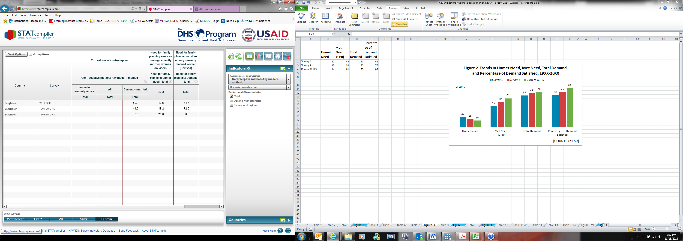

1. Enter the numbers from STATcompiler into the working table above Figure 2 in the Excel spreadsheet.
   1. Enter the data from the column titled “Currently married” into the SECOND column in the working table titled “Met need with modern methods (MCPR)”
   2. Enter data from the column titled “Need for family planning: Unmet need – total” into the FIRST column in the working table, titled “Unmet need”
   3. Enter data from the column titled “Need for family planning: Demand – total” into the FOURTH column in the working table titled “Total demand.” Note that this data will NOT (and must not) appear in the figure.
   4. The formulas in the locked cells in the THIRD column of the working table will automatically calculate “Percentage of demand satisfied with modern methods” and this column will display in the figure.











In countries where measles vaccination is not recommended before 12 months of age, the age range for this table should be changed to 18-29 months.

Add additional vaccinations in countries where these vaccinations are listed on the vaccination card, but do not include these vaccinations in the calculation of the percentage receiving “all basic vaccines”.



This table will not be included in the report, but the results will be mentioned in the text.



Delete reference to prepackaged ORS liquids for countries in which they are not available.













The numbers in this table correspond to Final Report Table 11.6, column 13.

NOTE:

The minimum acceptable diet indicator must be defined in the text of the Key Indicator Report. Children 6-23 months who have a minimum acceptable diet meet all three criteria below:

1. Breastfeeding; or not breastfeeding and receiving two or more feedings of commercial infant formula, fresh, tinned, or powdered animal milk, or yogurt.
2. Fed with foods from four or more of the following groups: a. infant formula, milk other than breast milk, cheese or yogurt or other milk products; b. foods made from grains, roots, and tubers, including porridge and fortified baby food from grains; c. vitamin A-rich fruits and vegetables (and red palm oil); d. other fruits and vegetables; e. eggs; f. meat, poultry, fish, and shellfish (and organ meats); g. legumes and nuts.
3. Fed the minimum recommended number of times per day according to their age and breastfeeding status:

For breastfed children, minimum meal frequency is receiving solid or semi-solid food at least twice a day for infants 6-8 months and at least three times a day for children 9-23 months.

For non-breastfed children age 6-23 months, minimum meal frequency is receiving solid or semi-solid food or milk feeds at least four times a day.





For purposes of the smoking adjustment, if a woman is not interviewed or if information is not available on whether or not a woman smokes, we assume that she is a non-smoker. In ever-married samples or in countries where smoking among women is common, this assumption may have to be modified.

The complete reference for CDC, 1998 is Centers for Disease Control and Prevention. 1998. Recommendations to prevent and control iron deficiency in the United States. *Morbidity and Mortality Weekly Report* 47 (RR-3): 1-29.







Table 7W and Figure 7 present the results for the Roll Back Malaria ITN indicator “Proportion of population with access to an ITN in their household.” The indicator is defined as the percentage of de facto household members who live in households which possess at least one ITN for every two de facto household members.















Note: in countries that measured malaria prevalence by RDT and microscopy, if prevalence results by microscopy are not available at the time the Key Indicators Report is prepared, prevalence estimates based on RDT alone should not be shown. Instead, Table 20 should be deleted.







This working table is produced to determine which misconceptions about the transmission of HIV are most common. Numbers in this table should be weighted. The most common and second-most-common misconceptions should be the same for females and males. The most common misconception is the one with the highest percentage of both men and women answering “YES” to the question. The second most common misconception is the one with the next highest percentage of both men and women answering “YES.”

If a subsample of households was used for the male sample, then the number of male respondents should be multiplied by the inverse of the proportion of households selected for the male subsample in order to generate the percentages for the total population.

Those answering “YES” to each misconception are used to identify the most common misconceptions. However, those answering “NO” to each misconception are included in those with knowledge of HIV prevention in Table 22.













**Notes to DP / analysts:**

1. **This table is based on women 15-49 and men 15-49 (except for the last three rows).**
2. **“Number”** = denominator for calculating prevalence = **Total number of DBS tested at the lab and with an interview**. These cases are identified in Table 17, Row 1 of each panel. Respondents tested but NOT interviewed are NOT included. Only DBS samples with a test result are included (i.e. positive, negative, or indeterminate).
3. **“Percentage HIV-1 positive”** include cases that are HIV-1 positive **AND** both HIV-1/2 positive(cases only HIV-2 positive must NOT be included).
4. Delete footnote in countries where HIV-2 is not measured.